Technical WritingAudience Analysis
Name
Institution
Date

Technical WritingAudience Analysis
Figure 1 below is a common sign which I have come across in different locations: at school, in commuter buses, malls, churches, among other places. In most places, the sign has been mounted at the entrances where the people can easily see it. Notably, the sign is made up of four words: “please wash your hand”, with a symbol illustrating the words' message. This is one of the most reasonable signs at the moment, considering that we are living through a Coronavirus pandemic; therefore, it urges the general public to frequently wash their hand as a way of preventing the spread of the virus. Arguably, most Americans must have come across a similar sign or seen it on the television. Notably, the sign presents particular characteristics of technical communication; that is, it is designed purposely to increase readability for the audience consisting of various words. Moreover, it addresses a particular audience with the aim of problem-solving.
Based on the above characteristics, it is obvious that the attached figure demonstrates every aspect. That is, the sign is designed to increases its readability for the audience. Evidently, the words have been printed in black with a white background to increase their visibility and readability for the audience. It has also added a symbol of illustrating the message of the sign to the audience (Killingsworth & Gilbertson, 2018). In addition, the sign is made up of words. That is, it consists of four simple words: please wash your hands, which can easily be interpreted by the audience. Besides, the words make sense to many because we are facing a global pandemic due to the Coronavirus, and the CDC had hugely advocated for the frequent washing of hands because the virus is easily transmissible when one comes into contact with contaminated areas. Therefore, by washing our hands, we can help curb the spread of the disease.
Arguably, the sign’s audience is the general public but particularly those who have the ability to see and read. Besides, the message of the sign can be interpreted by any audience, that is, if one can actually see and read the sign. Considering the times we are living in, the sign is meant for all types of readers that either tacit, reflective, strategic, or aware readers. Besides, the sign also helps solve a particular problem for the audience (Killingsworth& Gilbertson, 2018). That is, the sign is creating public awareness, encouraging people to wash their hands to help fight the spread of the Coronavirus. Additionally, the sign demonstrates the aspect of collaboration. That is, different people must have been involved in producing the sign, that is, from the designer to the peoples who mounted the sign at the entrances. In addition, these institutions seem to work hand in hand with the World Health Organization and the American Centre for Disease Control and Prevention in creating public awareness for the American citizens.
Besides, the current pandemic requires a collaborative attitude so as to win the fight against the virus by preventing the spread. Lastly, the sign demonstrates an institutional goal and culture. That is, by mounting this sign at the institution's entrance, it shows their commitment to fighting the spread of the Coronavirus. Hence, this shows that the organizations urge to create public awareness through the sign showing that they care about the people involved in these institutions (Killingsworth& Gilbertson, 2018). Besides, with the current global condition, every institution's objective is to ensure everyone's safety in their organizations; therefore, educating the people about the essence of washing their hands shows their commitment to preventing the spread of the virus.
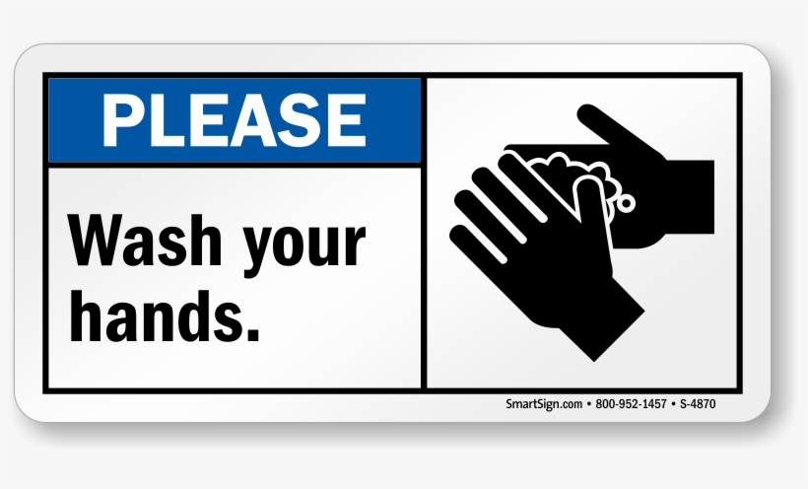
Figure 1.

References
Image retrieved from: https://www.amazon.com/Please-Wash-Hands-SmartSign-Plastic/dp/B007D5H6JS
Killingsworth, M. J., & Gilbertson, M. K. (2018). Signs, genres, and communities in technical communication. Routledge.

